Markov Decision Process
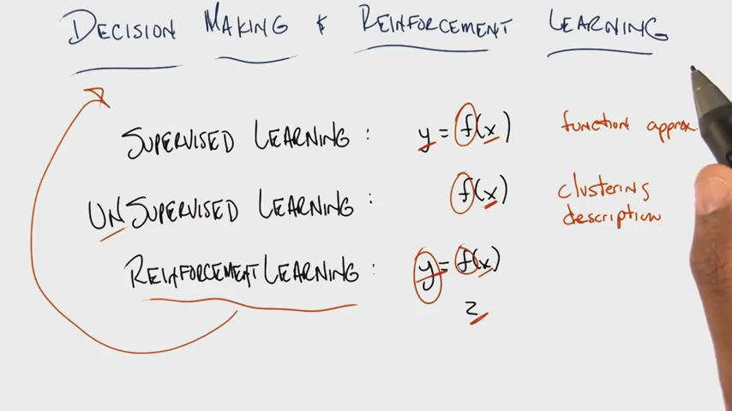
For reinforced learning, given x and z, and try to find function f that generates y
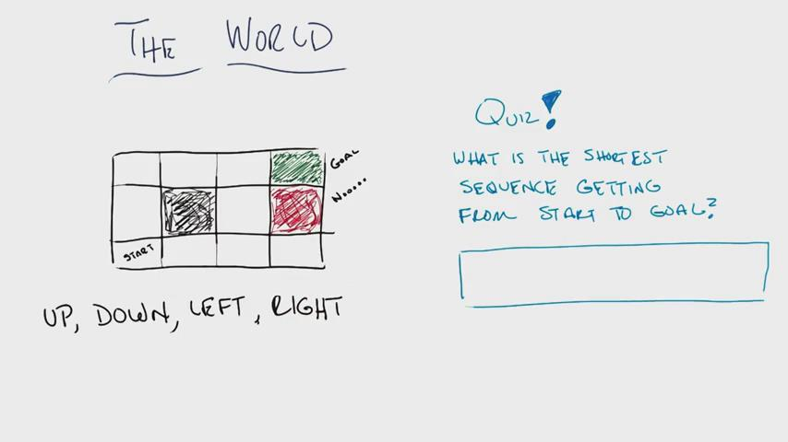
U, U, R, R, R or R, R, U, U, R
Usually multiple solutions available
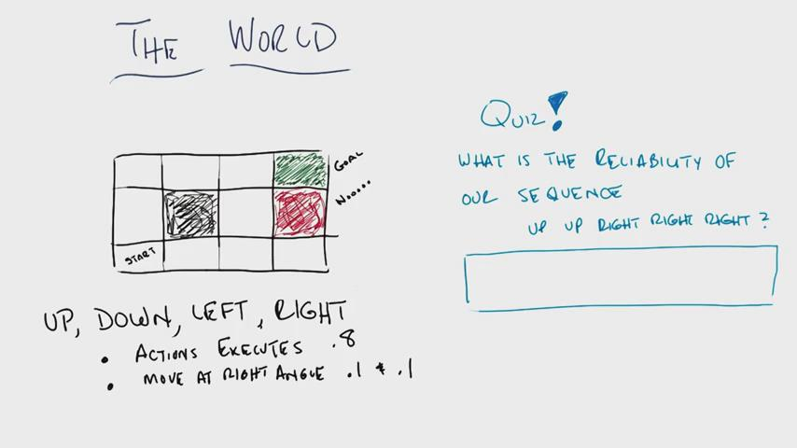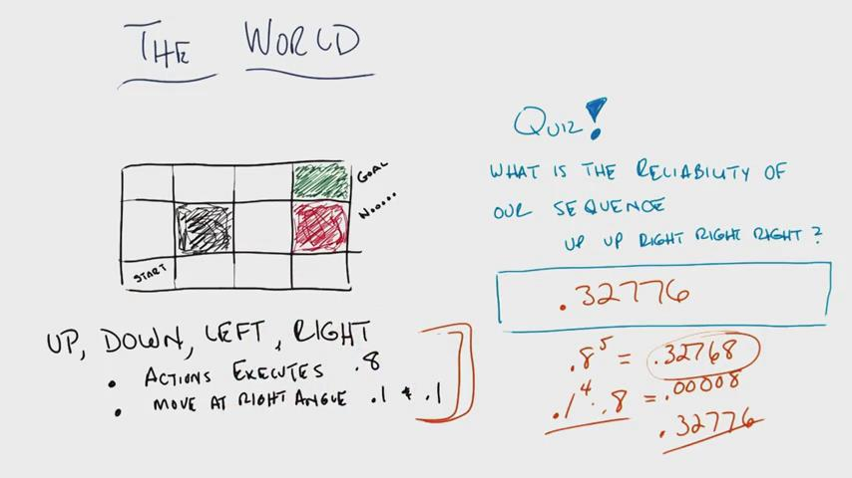
Stochasticity of movements
Need to consider the path to the right
Need to finish in green spot after 5 steps, no more steps available
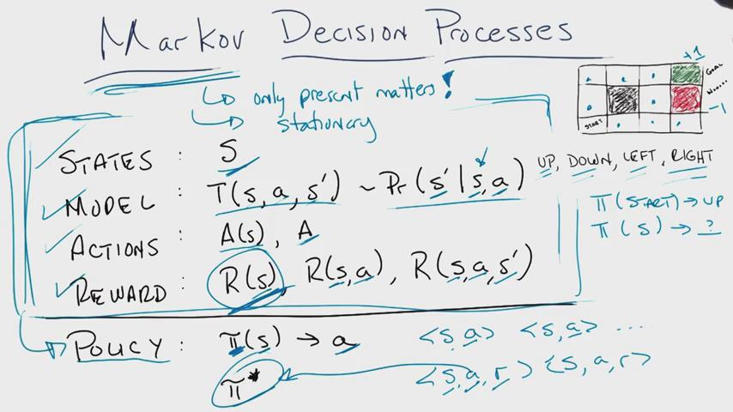
add historical states to make the process Markov
RL: given <state,action,reward> pairs as training samples, and try to find the optimal policy pi or optimal solution
SL: given <state,action> pairs as training samples, and try to find the optimal polity pi
Assumptions: you know which state S, and the reward for taking actions
Policy does not tell you the sequency of actions (i.e. plan) to reach success, but what actions to take at particular state
The problem: given the MDP, how to find the optimal policy pi?
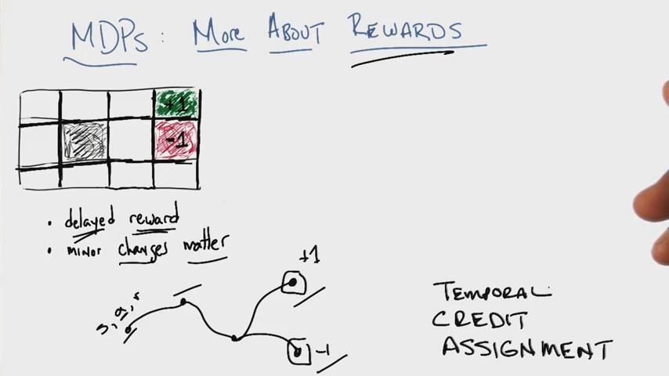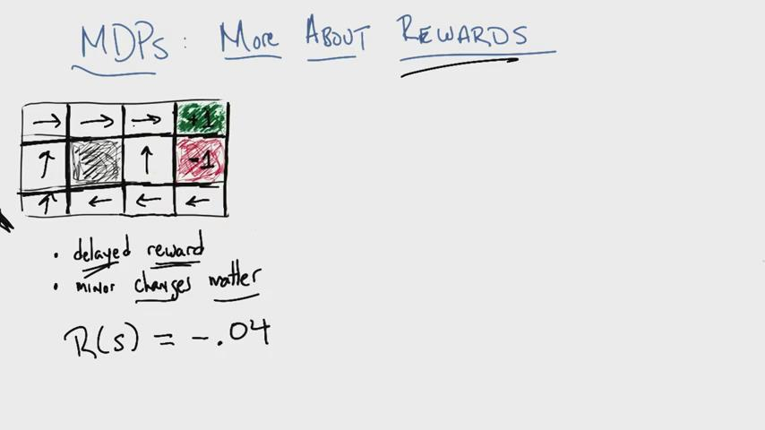
MDPs: more about rewards
Delayed rewards
Temporal credit assignment, where credit = 1 or -1
reward R(s) = -0.04 for each state except the terminating positions
The arrow the global optimal solution (or plan)
The reward function may change the global solution greatly: totally different path given different reward functions
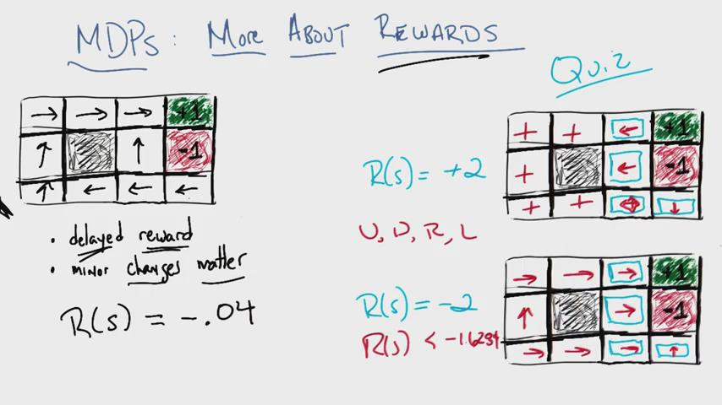
Big negative rewards to end game as soon as possible
Big positive rewards to continue game as long as possible
Medium negative rewards: in the game to get the +1 reward
Big positive rewards: just in the game
Big negative rewards: get out of game ASAP
Reward function is domain knowledge: if you want to use MDP to describe a world, you need to think carefully how you set up reward functions

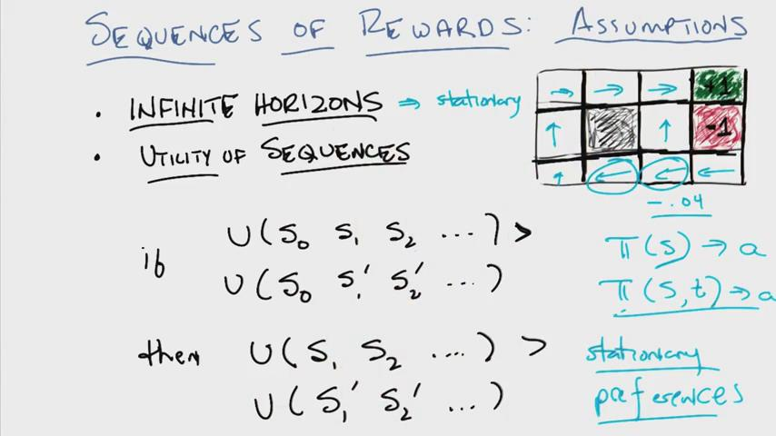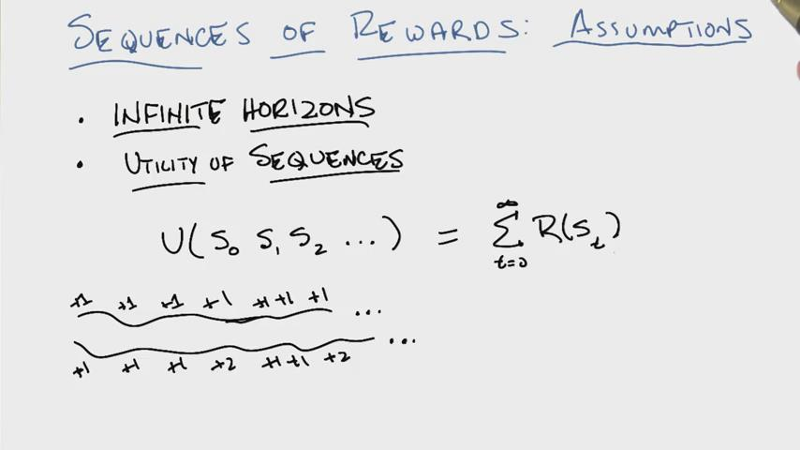
Infinite horizon: you can live for ever to try, till get the terminating states => need to consider reward function, as well as how much time left (i.e. horizon)
If the horizon is not infinite, for example, game ended within 3 steps when in state (3,1), then probably going UP is the right choice, instead of going left
In the infinite horizon, the process is stationary, where the action only depends on the state. Or, as long as I am at this particular state, I will always take the same action. Policy pi(S) -> a
In the finite horizon, the process is non-stationary, where the action may be different depending on how much time left at the same state. Policy pi(S,t) -> a
Utility of sequence (vs utility of a single step): U(s₀,s₁,…,)
Lemma (stationarity of preference): if U(S0,S1,S2,…)>U(S0,S1’,S2’,…) (utility of sequence starting at the same state s0), then
U(S1,S2,…) > U(S1’,S2’,…)
Or, if I prefer a sequence over another sequence today, then I prefer the same sequence tomorrow
Note: the utility of a sequence = sum of rewards along the path, then the Lemma is true. On the other hand, if Lemma is true for any sequence, then the utility of sequence = sum of rewards along the path.
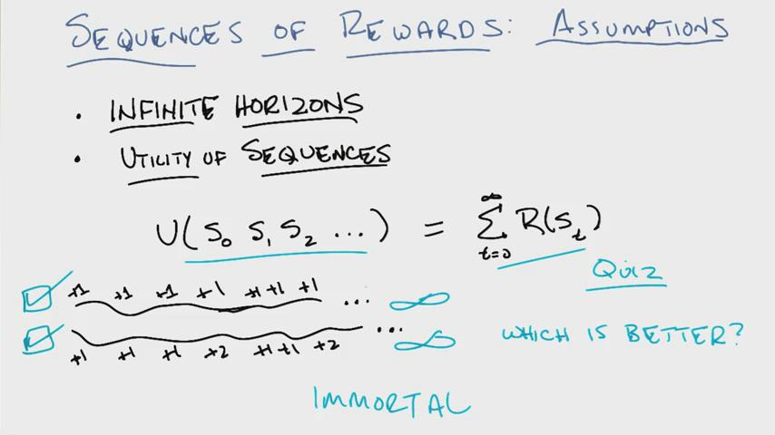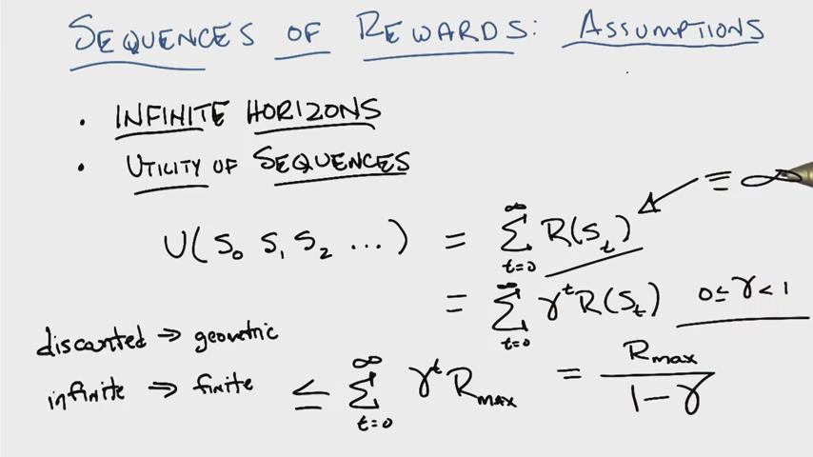
Discounted rewards by adding the factor gamma^t
Infinite horizon but finite total reward

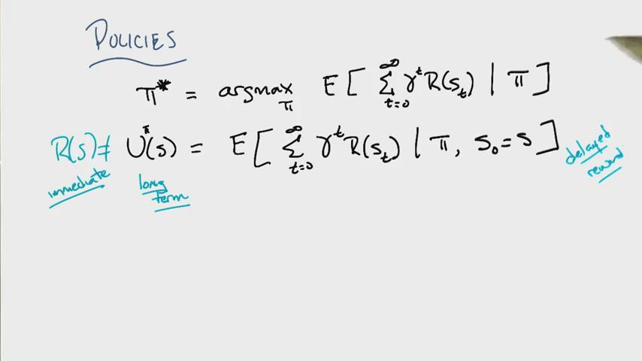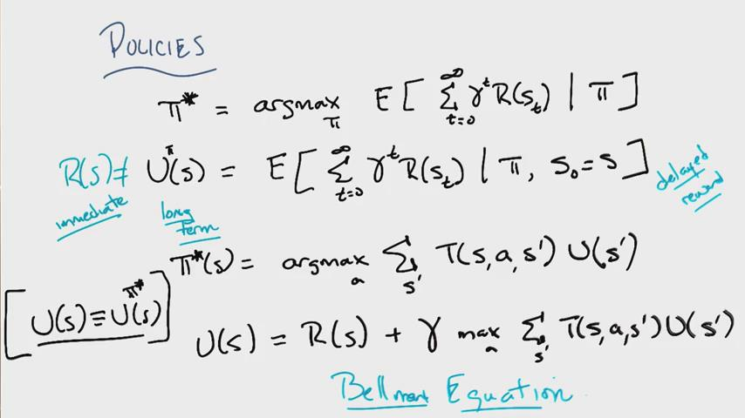
The optimal policy pi, will optimize the total expected discount rewards
The utility given policy pi is the expected total discount rewards given policy pi and starting state S
T(S,a,S’) is the transition probability that we start at state S and end up at state S’ under activation a
U(S) is the total discount rewards given optimal policy
Bellman equation is the key to solve MDP problem

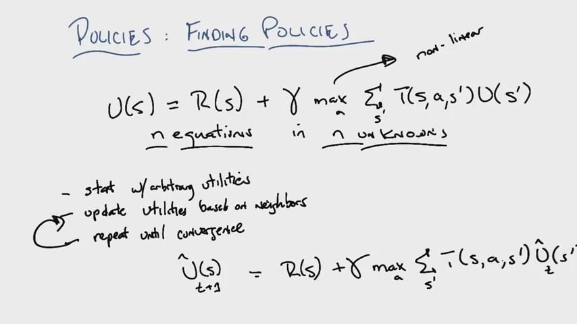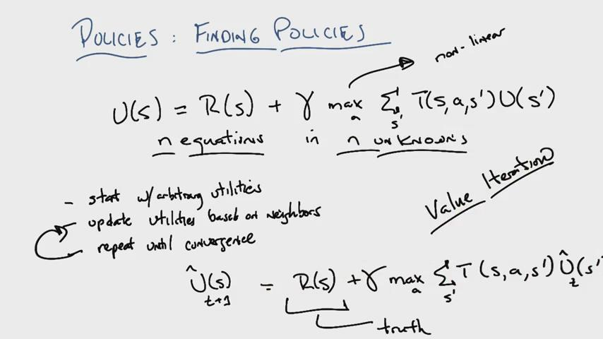
For Bellman equation, there are N equations with N unknowns, but max function make it not-linear => algorithm is used to solve these equations (called value iterations)
U_t(S) is arbitrary values, while R(S), the instant reward function, is the truth
Adding more truth through loop will converge to the solution
Value iterations: does not give you the right answer, but closer and closer answers
Once the utility function is solved, then it’s easy to solve the optimal policy pi

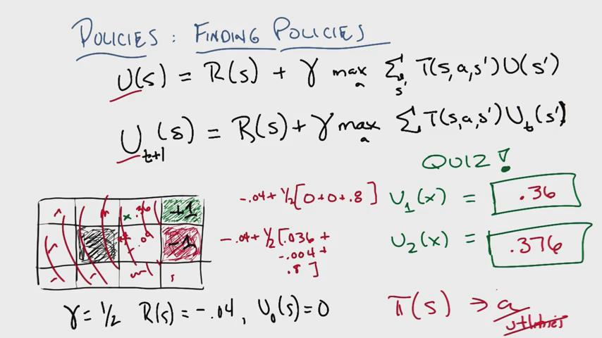
For state X, better to go to green spot with probability 0.8, while going to other two directions with probability 0.1
For t=2, we need to calculate the U(Y) at t=1 where Y is the grid below X: the optimal policy is to go to the wall, and back to the original state. However, at some point, when the utility of state X is big enough, the optimal policy would be go to state X, instead of wall
The value iteration works if eventually the value pops out its neighbors => +1 and -1 will pop out to states over time
Given utility, we can find policies; but given policies, it’s hard to find utility

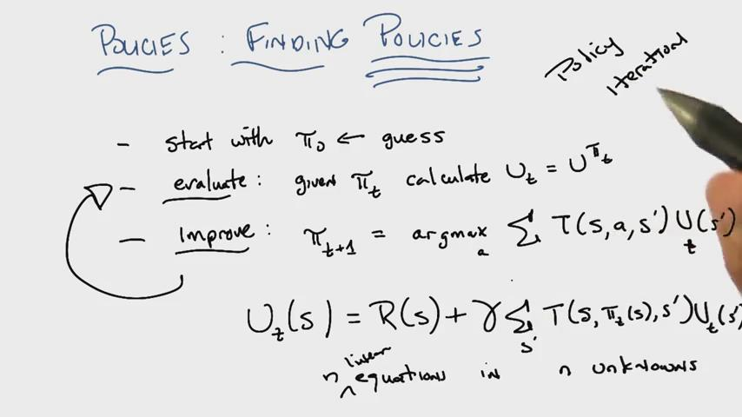
Given policy, we can remove the max function, and turn the Bellman equation into linear equation, and solve it
Called policy iteration
Guaranteed to converge: finite number of policies, and you are always getting better

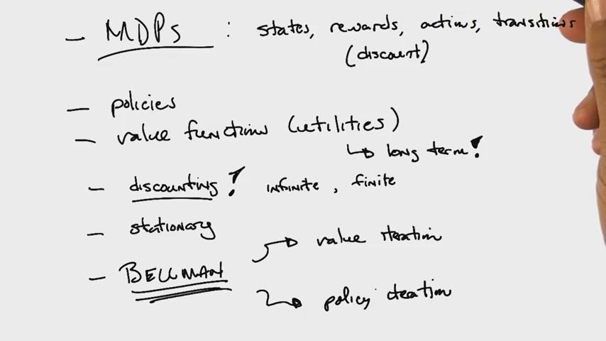
In RL, you don’t necessarily know the rewards and transitions

Markov Decision Process

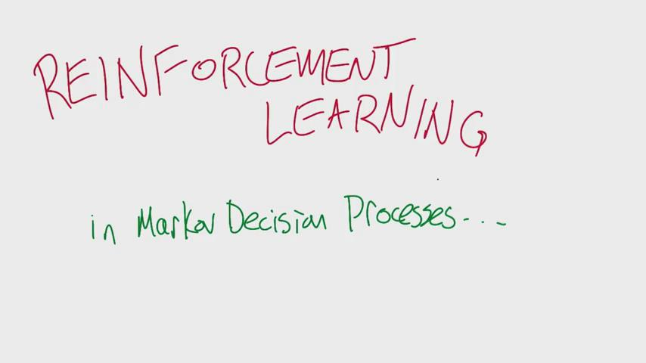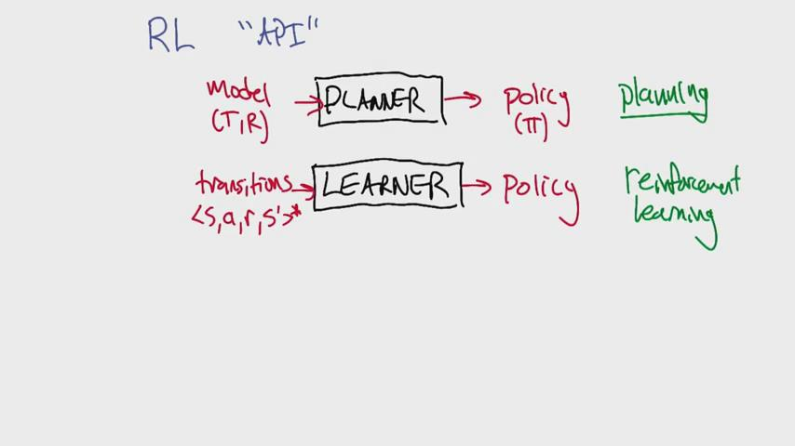
T: transition matrix; R: reward functions
\pi: S-> actions
Transitions: samples

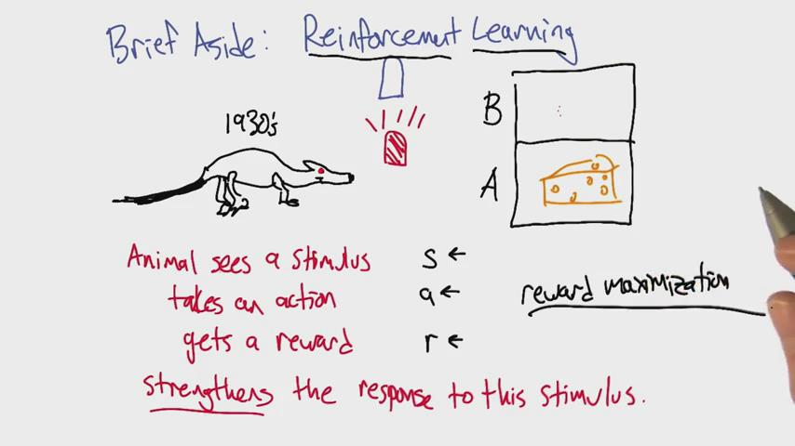
Stimulus: like seeing the red light <- state
Action: like picking box A <- action
Reward: like cheese <- reward
Strengthen: means next time sees red light, more likely to go to box A => reinforcing the connection
How to choose actions to maximize reward as a function of state => reward maximization

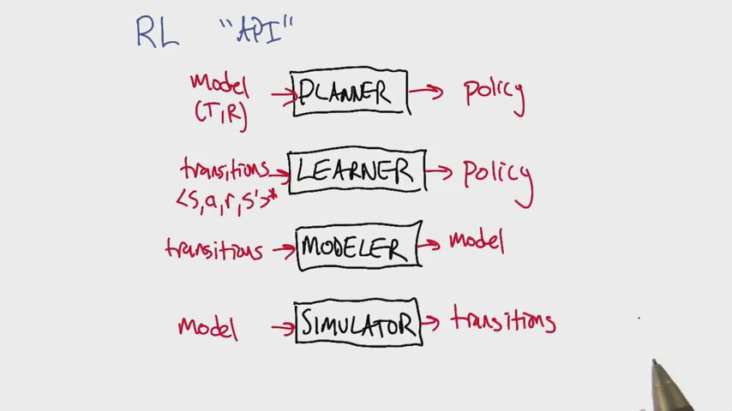
Modeling: like machine learning problem
Simulator: simulate samples, time consuming
One way to do learning: to do modeling and simulating, so that I know a modle and what the reinforcement function was, and just do planning

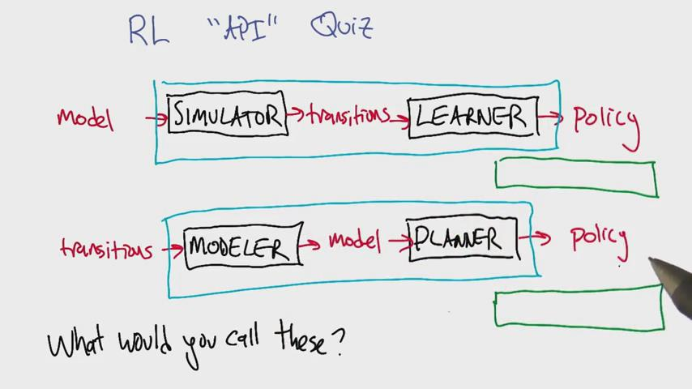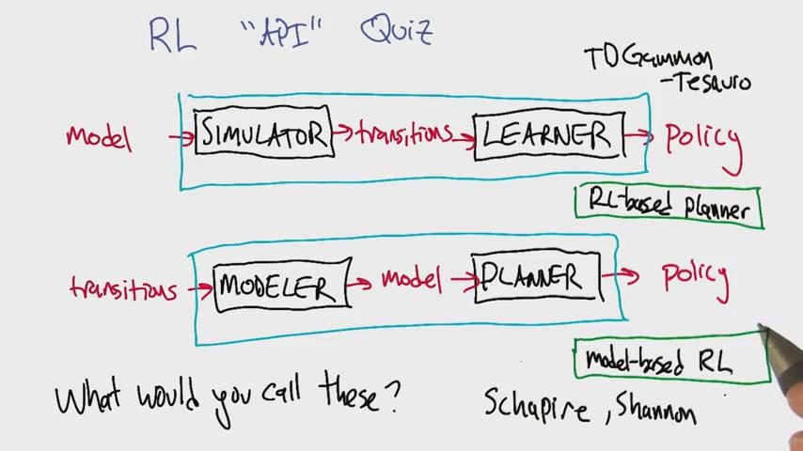

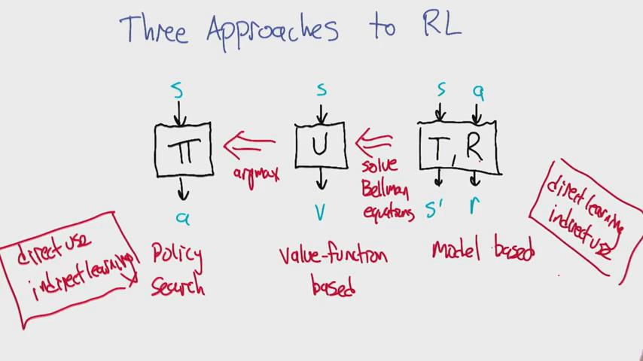
3 outputs of RL algorithms: policy search algorithm; value-function based algorithm; model-based RL learner
From utility to policy: use argmax operation
From model to utility: value iteration to solve Bellman equation
Model based RL learning: direct learning, not-direct usage
We will focus on the second: value-function based learning: medium direct learning and usage
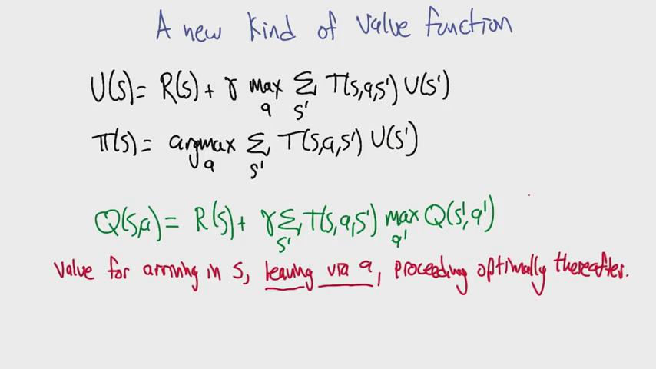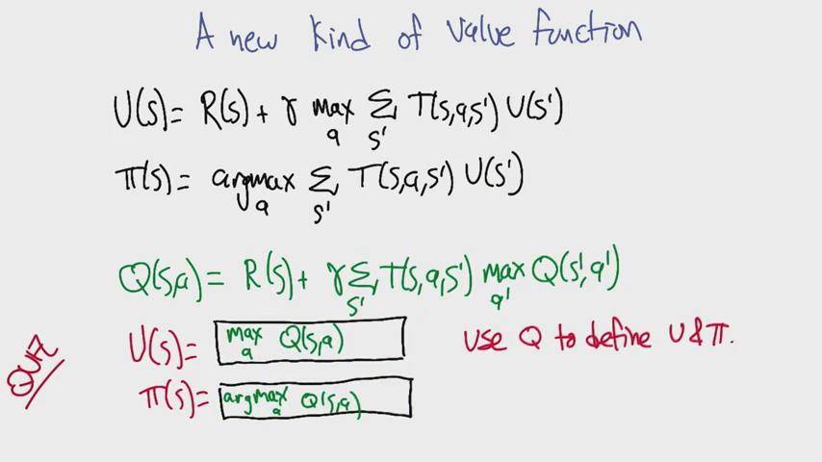
Q(S,a) is the reward taking a specific action => we can take Q as U, if we always take the best action. The best action is the one maximize the utility (value you get from that point on)

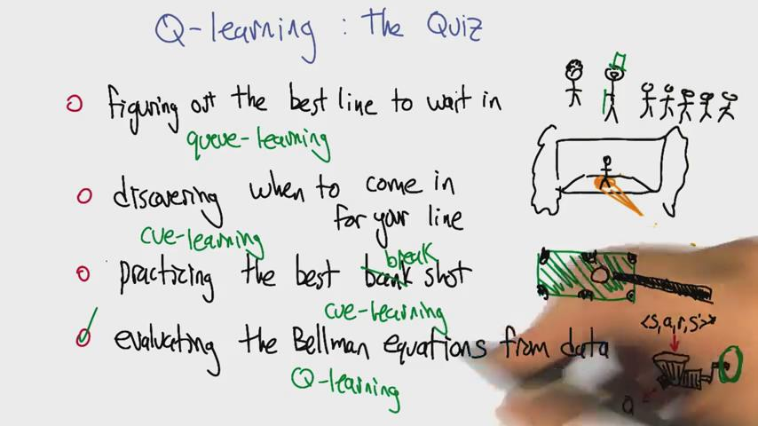

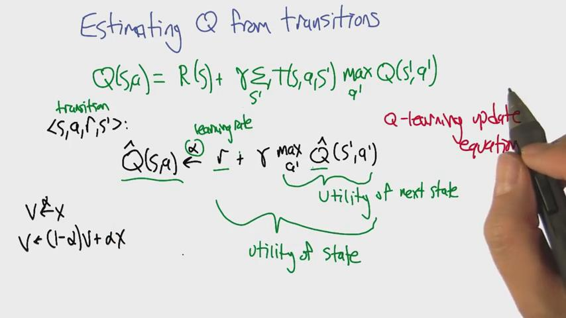
We don’t have access to R(S) and T(S,a,S’). if known, we can use value iteration and policy iteration to solve Bellman equation for Q(S,a)
<S, a, r, S’>: we are in state S, take the action a with reward r. The new state is S’
V<-alpha X: current state is V, and move alpha toward state X
V<- (1-alpha)V + alpha X

